OFFICE OF RESEARCH, INNOVATION AND COMMERCIALIZATION (ORIC) University of Engineering and Technology, Lahore

MSc Thesis Proposal

Title: "Early Detection of Lung Cancer Nodules through Capsule Neural Network: An Advanced Deep Learning Approach for Medical Imaging"

Student Details:
Name of Student: Aizaz Shabber Khan
Registration No: 2024(S)-MS-DS-06
Full Time: Yes

Supervisor: Dr Ayesha Altaf
Department: Data Science

1. Problem Statement
Lung cancer is one of the most common cancers globally and remains a leading cause of mortality. Although CT screening has proven effective in reducing lung cancer–related deaths through early detection [9], accurate diagnosis continues to present challenges. Computer-Assisted Diagnosis algorithms play a crucial role in enhancing both the quality and cost-effectiveness of lung cancer detection by providing structured assessments of nodule size, localization, and follow-up recommendations [2].
Capsule Neural Networks (CapsNets), introduced by [4], were designed to address these limitations by preserving spatial information and hierarchical relationships through dynamic routing [4]. Unlike CNNs, CapsNets maintain spatial invariance and can recognize objects regardless of position, potentially improving performance even with smaller datasets. Despite these theoretical advantages, their application to lung nodule detection remains underexplored. There is a pressing need to investigate whether CapsNets can reduce false positives and improve diagnostic accuracy compared to CNN-based systems in lung cancer screening. The research gap lies in the lack of comprehensive comparative studies between CNN and CapsNet models for lung nodule detection, the absence of empirical validation of CapsNets’ spatial awareness benefits in medical imaging, and limited research on the computational efficiency and deployment feasibility of CapsNet-based diagnostic systems in real-world healthcare environments [9].

2. Research Objectives
• To analyze the limitations of traditional CNN-based approaches in lung nodule detection, particularly focusing on spatial information loss due to pooling operations and high false positive rates caused by blood vessel structures [5][8].
• To design and implement Capsule Neural Network architectures specifically optimized for lung nodule detection using CT scan images, incorporating dynamic routing algorithms and spatial preservation mechanisms [4].
• To develop and evaluate multiple CapsNet architectures capable of classifying CT scan regions into nodule and non-nodule categories with enhanced spatial awareness compared to traditional CNN approaches [1][7].
• To assess the impact of CapsNet implementation on prediction metrics such as accuracy, sensitivity, specificity, and false positive reduction using the LIDC-IDRI dataset and standard evaluation protocols [6].
• To address computational efficiency and deployment concerns associated with CapsNet-based lung cancer detection systems, and propose frameworks for practical integration in healthcare screening programs [3].

3. Industrial Collaboration No

4. Literature Survey
The application of deep learning techniques in medical imaging has gained significant momentum, particularly in lung cancer detection and diagnosis. Traditional approaches using Convolutional Neural Networks have shown promise but face inherent limitations that affect their practical deployment in healthcare settings.
[9] emphasized that lung cancer remains a leading cause of cancer-related deaths globally, making early detection through automated systems crucial for improving patient outcomes. The importance of computer-aided diagnosis in lung cancer screening has been further validated by [2] who demonstrated that CT screening can significantly reduce mortality rates when combined with effective diagnostic algorithms.
Convolutional Neural Networks have been extensively applied to lung nodule detection tasks. [8] conducted a comprehensive evaluation of CNN models for lung nodule classification using the LIDC-IDRI dataset, achieving 84.15% accuracy with CNN, 83.96% sensitivity, and 84.32% specificity. However, their work highlighted the persistent challenge of false positive rates and the need for extensive data augmentation to achieve optimal performance.
The limitations of CNN architectures in preserving spatial information have been well-documented. [5] analyzed the impact of pooling operations on feature preservation, demonstrating that max pooling, while computationally efficient, leads to significant information loss. This limitation is particularly problematic in medical imaging where spatial relationships between anatomical structures are crucial for accurate diagnosis.
[1] explored deep learning approaches for lung nodule classification, using deep features in CT images and achieving promising results. However, their work also revealed the challenges associated with CNN-based approaches, including the requirement for large datasets and susceptibility to overfitting when dealing with limited medical data.
Addressing the need for more sophisticated architectures, [7] investigated deep CNN models for computer-aided detection, examining various architectures with parameters ranging from 5 thousand to 160 million. They achieved 85% sensitivity at 3 false positives per patient but noted the persistent challenges in spatial feature preservation and generalization.
The introduction of Capsule Neural Networks by [4] marked a significant advancement in addressing CNN limitations. Their dynamic routing algorithm enables better preservation of spatial hierarchies and part-whole relationships, potentially offering superior performance in object detection tasks with reduced data requirements.
Recent validation studies have further emphasized the importance of robust evaluation methodologies. [6]conducted large-scale validation of automatic pulmonary nodule detection algorithms through the LUNA16 challenge, establishing standardized protocols for performance evaluation and comparison across different approaches.
The National Lung Screening Trial Research Team [3]provided crucial evidence supporting the effectiveness of low-dose computed tomographic screening in reducing lung cancer mortality, establishing the clinical foundation for automated detection systems.
Together, these studies establish a strong foundation for investigating Capsule Neural Networks as an alternative to traditional CNN approaches in lung nodule detection, offering potential improvements in spatial awareness, reduced false positive rates, and enhanced performance with limited datasets.

Year | Title & Authors | Research Purpose | Model | Dataset / Statistics | Evaluation Measures | Limitations & Research Gap
2017 | Sabour et al. – Dynamic Routing Between Capsules | Introduce CapsNet architecture to preserve spatial information | Capsule Neural Network with Dynamic Routing | MNIST, CIFAR-10 | Accuracy, routing iterations | Limited testing on medical imaging; computational complexity
2017 | Song et al. – Deep Learning for Lung Nodule Classification | Compare CNN models for nodule detection | CNN, DNN, SAE | LIDC-IDRI dataset | Accuracy (84.15%), Sensitivity (83.96%), Specificity (84.32%) | High false positive rates; requires extensive augmentation
2016 | Setio et al. – LUNA16 Challenge | Validate automatic pulmonary nodule detection | Various algorithms | LUNA16 dataset (888 CT scans) | FROC analysis, sensitivity | Algorithm-specific limitations; need for ensemble methods
2016 | Shin et al. – CNN for Computer-Aided Detection | Evaluate CNN architectures for medical detection | Deep CNNs (5K–160M parameters) | Thoraco-abdominal datasets | 85% sensitivity at 3 FP/patient | Transfer learning challenges; domain adaptation issues
2015 | Kumar et al. – Deep Features for Lung Nodules | Use deep features for nodule classification | Auto-encoder based CNN | LIDC dataset (4303 samples) | 75.01% accuracy, 83.35% sensitivity | Limited feature representation; overfitting concerns
2014 | Stewart & Wild – World Cancer Report | Analyze global cancer statistics and trends | Statistical analysis | Global cancer databases | Mortality rates, incidence | Lack of automated detection systems
2011 | NLSTR Team – Lung Cancer Screening | Evaluate low-dose CT screening effectiveness | Clinical trial | 53,454 participants | 20% mortality reduction | Manual interpretation; radiologist dependency
2010 | Scherer et al. – Pooling Operations Evaluation | Compare pooling methods in CNNs | CNN with various pooling | ICANN benchmark datasets | Recognition accuracy | Information loss in max pooling; spatial invariance issues

Methodology
This research will follow a systematic experimental approach to develop and evaluate Capsule Neural Network architectures for lung nodule detection. The methodology consists of the following key steps:
Dataset Collection and Preprocessing
- Use the LIDC-IDRI dataset as the primary source of CT scan images, containing 1018 CT scans from 1010 patients with nodules annotated by radiologists.
- Preprocess the data including resizing images to 32x32 and 48x48 pixels, normalization, grayscale conversion, and handling class imbalance.
Capsule Neural Network Architecture Design
- Develop three distinct CapsNet architectures with varying complexity levels to optimize performance for nodule detection.
- Implement encoder-decoder structure with convolutional layers, primary capsule layers, and class capsule layers using dynamic routing algorithms.
Data Augmentation and Training
- Apply data augmentation techniques including rotation (45°, 60°, 90°), flipping, and contrast adjustment to address dataset imbalance.
- Implement training methodology using Adam optimizer, batch normalization, and leaky ReLU activation functions.
Model Development and Comparison
- Train three CapsNet architectures separately:
  - Architecture 1: Basic CapsNet with 32 primary capsules (32x32 input)
  - Architecture 2: Enhanced CapsNet with 64 primary capsules and improved regularization (32x32 input)
  - Architecture 3: Advanced CapsNet with optimized parameters (48x48 input)
- Compare performance against traditional CNN baselines using the same dataset.
Evaluation and Analysis
- Evaluate models using accuracy, sensitivity, specificity, and false positive rates.
- Conduct statistical analysis to assess significant improvements over CNN approaches.
- Analyze computational efficiency and training time requirements.
Implementation Framework
- Software/Tools: Python 3.x, PyTorch, TensorFlow, NumPy, OpenCV for image processing, Matplotlib for visualizations.
- Hardware: GPU-accelerated workstation (Tesla K80 or equivalent) for efficient training.
- Data Management: Secure storage with version control using Git for reproducibility.
- Evaluation Metrics: Accuracy, Precision, Recall, F1-Score, ROC-AUC, and False Positive Rate per patient.
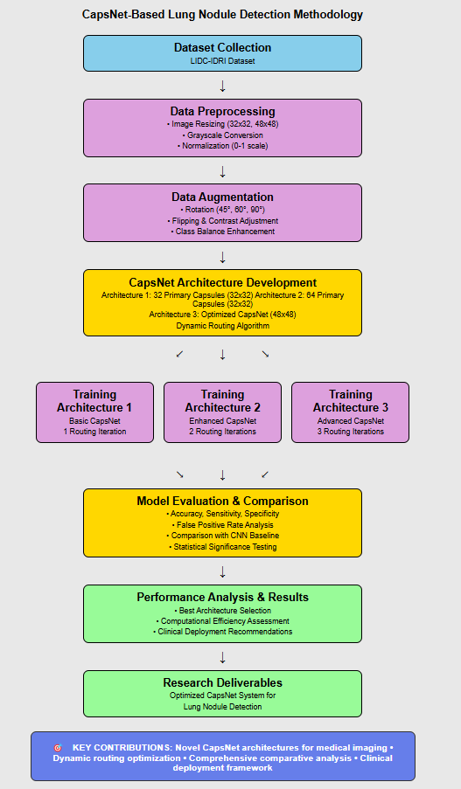

Utilization of Research Results

The research findings will have significant applications in healthcare AI systems, particularly in early lung cancer detection and screening programs. By implementing Capsule Neural Networks for nodule detection, the study aims to demonstrate how advanced deep learning architectures can enhance diagnostic accuracy while reducing false positive rates [4][8]. Hospitals and healthcare researchers can utilize these outcomes to improve automated screening systems, build more reliable computer-aided diagnosis tools, and support large-scale lung cancer screening programs, especially in regions with limited radiological expertise [7][1].Furthermore, the research will contribute to the academic community by providing methodologies for applying CapsNets to medical imaging tasks and establishing performance benchmarks for future comparative studies [3][6].

7. Research Outcomes and Deliverables
The primary outcome of this research will be the development of an automated lung nodule detection system using Capsule Neural Networks that demonstrates superior spatial awareness and reduced false positive rates compared to traditional CNN approaches. The key deliverables include three optimized CapsNet architectures specifically designed for lung nodule detection with varying complexity levels and input image sizes, a comprehensive performance evaluation comparing CapsNet and CNN approaches using the LIDC-IDRI dataset, and detailed analysis of computational efficiency and practical deployment considerations[1]. Additionally, the research will produce technical documentation including network architecture specifications, training protocols, and evaluation methodologies, along with a complete implementation framework in PyTorch that can be utilized by other researchers. The final deliverables will include visual representations of detection results, confusion matrices, and ROC curve analyses, culminating in a comprehensive thesis that documents the methodology, experimental findings, and recommendations for clinical deployment of CapsNet-based lung cancer screening systems[2][3].

8. Research Timetable

Month | Activities
Month 1 | Literature review completion, dataset acquisition (LIDC-IDRI), and initial data exploration
Month 2 | Data preprocessing, image normalization, and augmentation pipeline development
Month 3 | Implementation of CapsNet Architecture 1 and initial training experiments
Month 4 | Development of Architecture 2 and 3, hyperparameter tuning and optimization
Month 5 | Comprehensive training of all three architectures, performance evaluation, and comparison
Month 6 | CNN baseline implementation, comparative analysis, and statistical significance testing
Month 7 | Results analysis, visualization creation, computational efficiency evaluation, and documentation
Month 8 (optional) | Thesis writing, final revisions, and defense preparation

9. References
[1] Kumar, D., Wong, A., & Clausi, D. A. (2015). Lung nodule classification using deep features in CT images. IEEE 12th Conference on Computer and Robot Vision.
[2] Kauczor, H. U., et al. (2015). ESR/ERS white paper on lung cancer screening. European Respiratory Journal.
[3] N.L.S.T.R. Team, et al. (2011). Reduced lung-cancer mortality with low-dose computed tomographic screening. New England Journal of Medicine, 365, 395-409.
[4] Sabour, S., Frosst, N., & Hinton, G. E. (2017). Dynamic routing between capsules. arXiv preprint arXiv:1710.09829.
[5] Scherer, D., Müller, A., & Behnke, S. (2010). Evaluation of pooling operations in convolutional architectures for object recognition. International Conference on Artificial Neural Networks (ICANN), 92-101.
[6] Setio, A. A. A., et al. (2016). Validation, comparison, and combination of algorithms for automatic detection of pulmonary nodules in computed tomography images: the LUNA16 challenge. arXiv preprint arXiv:1612.08012.
[7] Shin, H. C., et al. (2016). Deep convolutional neural networks for computer-aided detection: CNN architectures, dataset characteristics and transfer learning. IEEE Transactions on Medical Imaging.
[8] Song, Q., Zhao, L., Luo, X., & Dou, X. (2017). Using deep learning for classification of lung nodules on computed tomography images. Journal of Healthcare Engineering.
[9] Stewart, B. W., & Wild, C. P. (2014). World cancer report 2014. International Agency for Research on Cancer.

Comments of Supervisor

It is expected that the supervisor comments on the stated suitability of the topic, objectives, and relevance to the larger research domain of the department and university.

Signature of Supervisor | Signature of Student
Endst. No. Univ:______________ | Dated: _____________

The above proposal duly recommended by the Departmental Board of Studies/Committee of
Post-Graduate Studies in its meeting held on _____________ is forwarded to the Director ORIC for obtaining the approval of the Vice-Chancellor.

___________________________ | ______________________________
Dean of the Concerned Faculty | Chairman/Director of the Department

